**National University of Computer and Emerging Sciences, Karachi Campus**

**RENT A CAR**

**CS2005 Database Systems**

**Project Proposal**

**BS(CS) – A**

Group Members:

Ariba 19K-0252

Anjiya Saleem 19K-0254

**Introduction:**

The system provides car rental services, where the car owner will lend his car and the customer will lease his car. This system will aid the person who wants to commute and is ready to make earning by lending his car; he can lend it to a person who wants to lease it. The system will work as a moderator between the customer and the car owner.

**Description:**

The system is divided into two ends-Customer and car owner. Each customer has a name, unique CNIC, email, residential address, phone number, driving license, comment(This will be noted by admin about our experience with him), and the car he rents. All these details will be stored in the database as Customer Personal Details. We keep track of status (whether the car is current-if he has not returned the car or released-if he has returned the car).A customer can lease exactly one car (subjected to his CNIC).

The database will store each car owner's name, unique CNIC, email, residential address, phone number and date. All these details will be accumulated in the database. We keep track of Date of car issuance (when the car owner brought his car to us), Date of car return (when the car owner took back his car), and the number of days the car was rented, in New Entry by Owner. A car owner may register his multiple cars on his CNIC. We present the quota to the car owner, by calculating the amount based on the car body type features and the commission earned on the car rented. The database will store the experience we had with the car owner as comments.

Each car issued will have a unique number plate, manufacturing year, make name, model name, number of days and car image. We keep track of Date of car issuance (when the customer rented the car),Date of car return (when the customer returned the rented the car) and status (whether the car is current-when all the cars are still under our custody or released-when all the cars are taken back by the car owner).These details will be stored under car. Each car will be associated to an owner who registers his car on CNIC.

The database will store car Body Type to store car type and the amount considering the car body type.

The database will preserve the car owner information such as Number plate of his car, customer CNIC, Issuance Date, Return Date and the amount for future referencing. Concurrently, the database will also store the customer information such as Number plate of his car, and his Customer's CNIC also meant for future referencing.

Each car will possess number of features such as car's body type, mileage, engine capacity, number of seats, transmission(automatic or manual), air conditioner, wireless technology(Radio, speaker, Bluetooth etc.),exterior color. Car’s body type will help us decide a tag price for the car.

The admin will have to leverage to edit posts, status and write comments in the database of owner and customer both. Therefore, admin will have unique admin ID, Name account ID and password.

**Entity Relationship Diagram:**

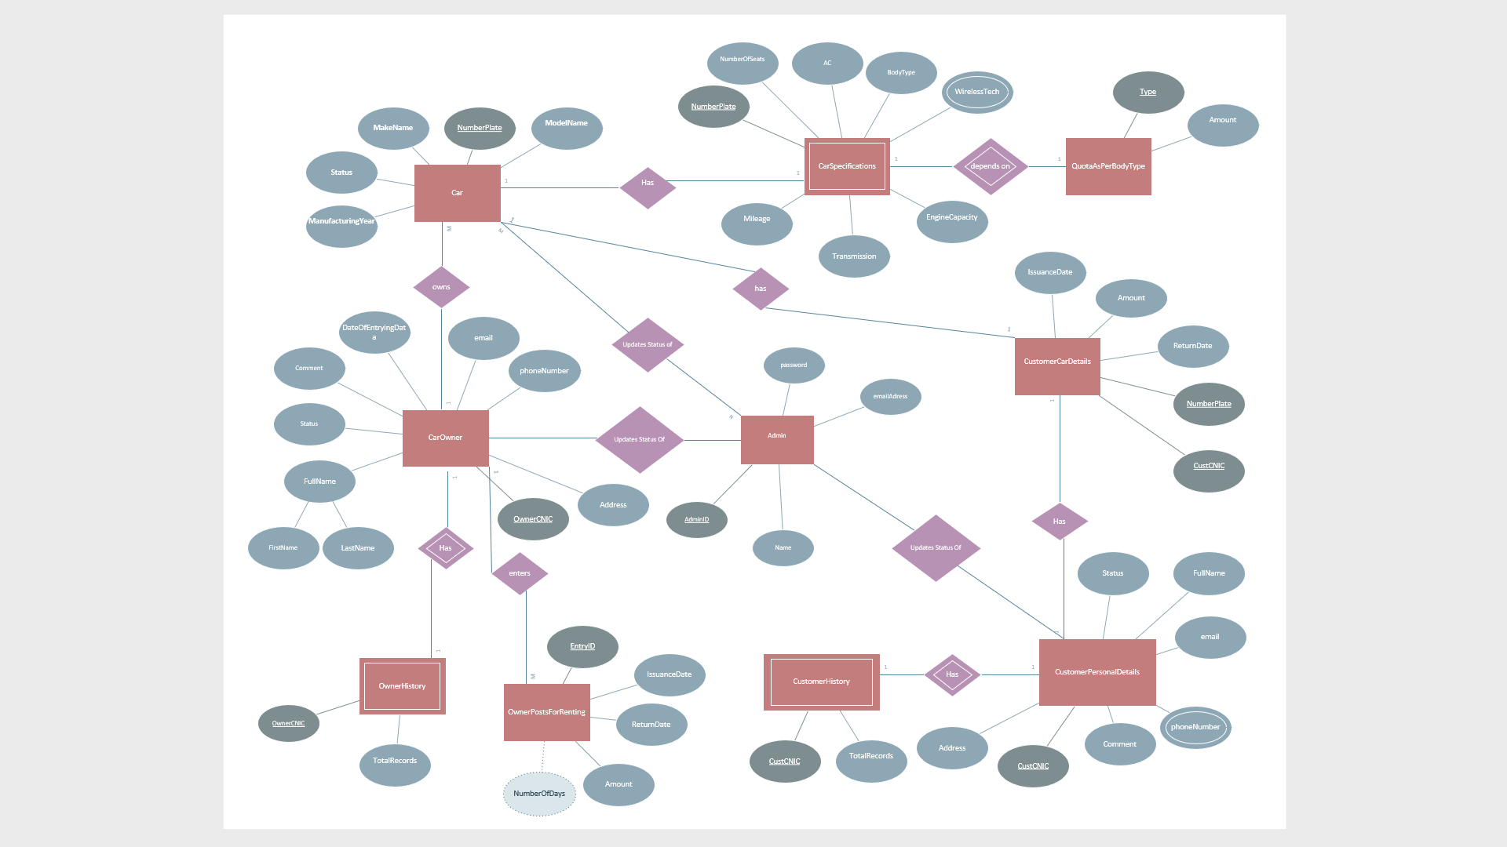

**Tools and Technology:**

1. Mysql Workbench
2. Node.js (Backend technology)
3. HTML, CSS (Frontend technology)
4. Visual Studio Code 201
5. Google chrome